**Termwork 8**

**Name : Chetan Jain**

**USN : 2GI20CS030**

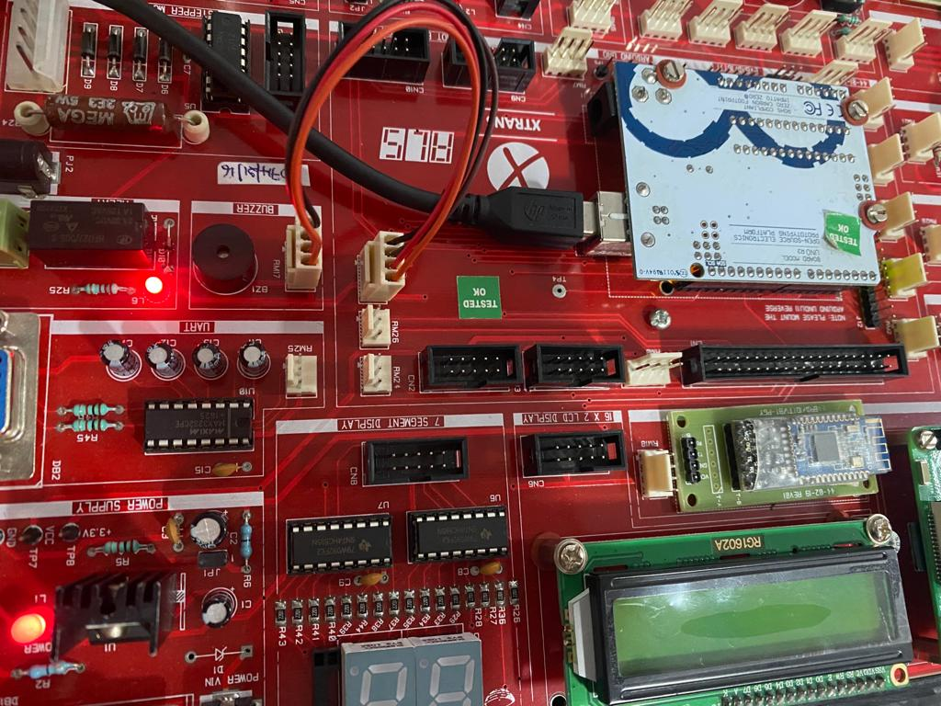**Relay ON :**

Relay OFF :

